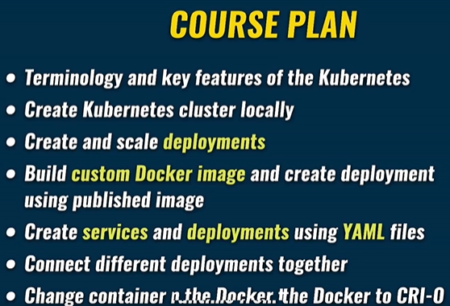

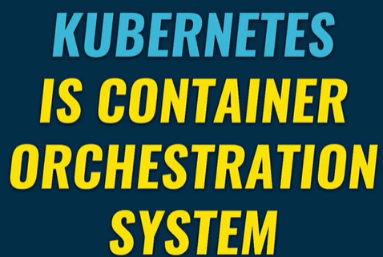

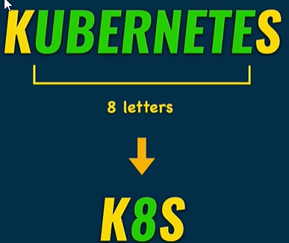

Using docker you could create a container on any computer. For creating multiple containers on different servers/computers you could get into trouble. Kubernetes allows that, in physical or virtual servers.

Kubernetes takes care of the automatic deployment of the containerized services across different servers.

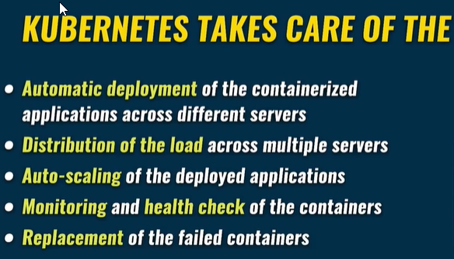Distribution of the load across different servers.

Autoscaling of the deployed applications.

Monitoring and health check of the containers.

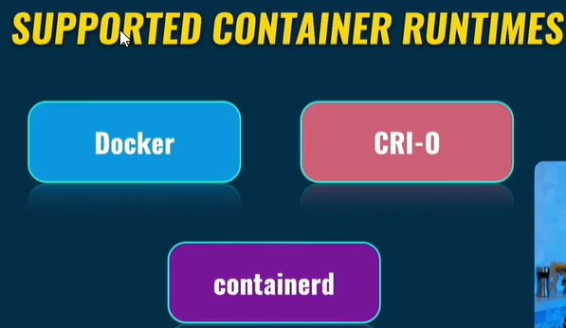Replacement of the failed containers.

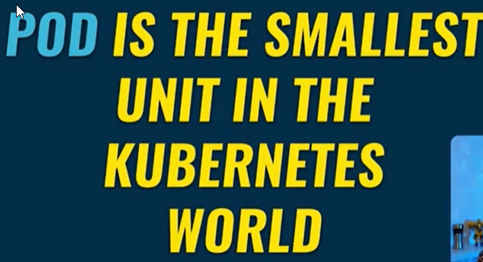Thus Kubernetes can run without Docker at all.

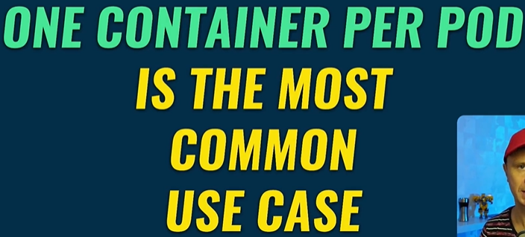

Containers are inside the pod. All containers inside the pod share the same volumes and the same IP Address.

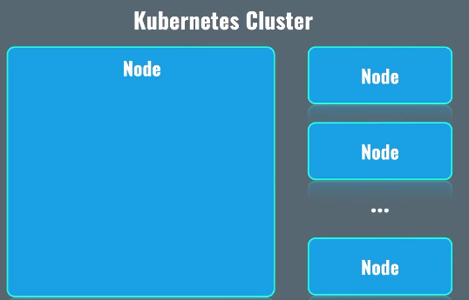One pod: One server, more servers not possible.

Kubernetes Cluster consist of nodes, nodes are nothing but server either bare-metal or virtual server.

Usually nodes which are in the same Kubernetes cluster, are located close to each other.

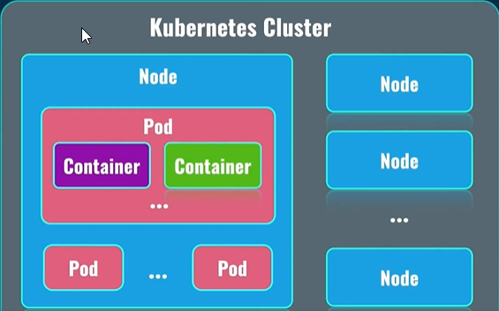Inside of the nodes, there are pods. Pods are the again, smallest possible unit in Kubernetes.

Inside the pods, there are containers, usually single containers per pod. Such pods are created on different nodes. All of this is done automatically for you. Your job is to create such nodes, and form clusters, based on those nodes. Nodes will not automatically form cluster without intervention.

But after such intervention, everything will be automated. Kubernetes will automatically form pods on different nodes.

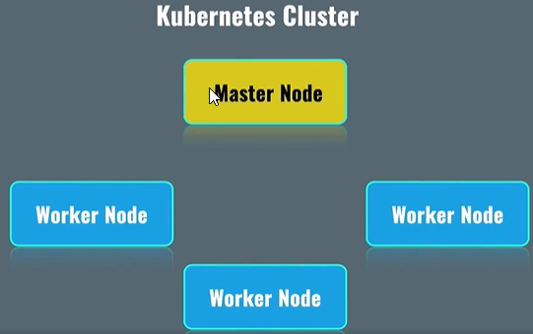How the nodes communicate with each other and how are they managed:

Master Node’s job to manage worker nodes. Distribute load across worker nodes. All pods related to your applications are deployed on worker nodes. Master Nodes work on system pods, which are responsible for actual work on system pods in general.

Kubernetes Services:

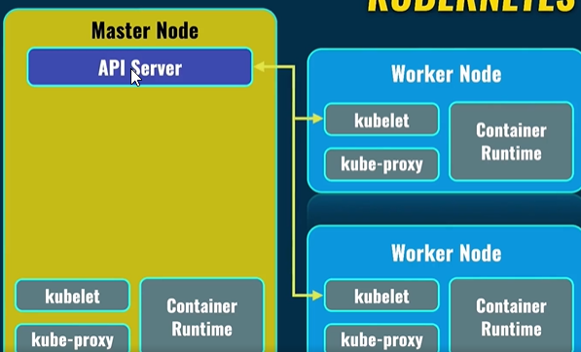Container Runtime: It runs actual containers inside of each node. Some container runtimes are docker, crio and container-d.

Kubelet: Communicates with API Server service in the master node. API Server service is the main point of communication between different nodes and inside of each node in the Kuberenetes world.

Scheduler: Load distribution.

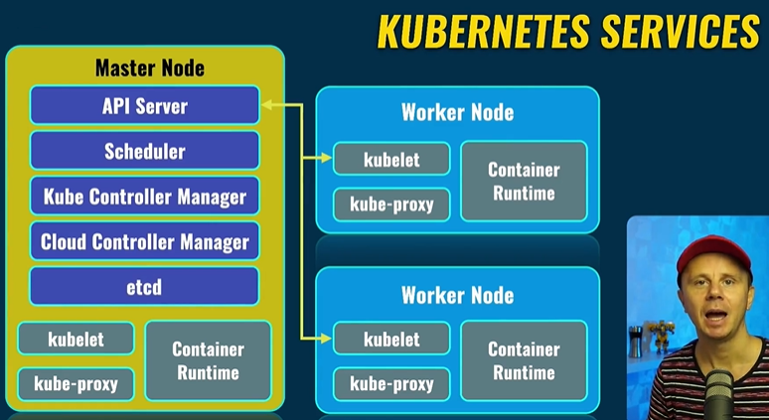Cloud Controller Manager: Interact with the cloud provider.

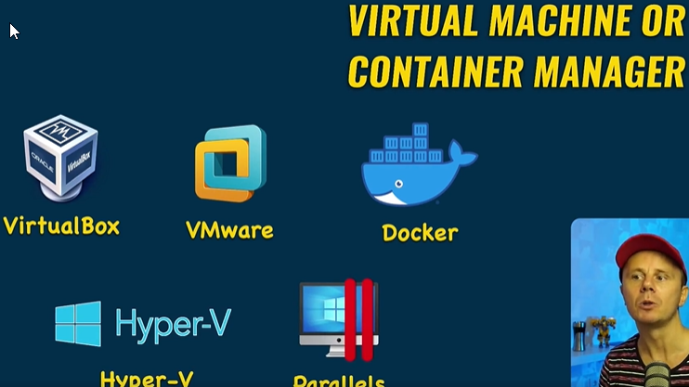Kubectl: Kube Control manages cluster.

Create Cluster for free, with one node, which will be both worker node and master node.

To run minikube successfully virtual machine or container manager is required.

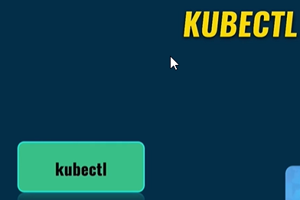Don’t use Docker since crio or containerd options not available.

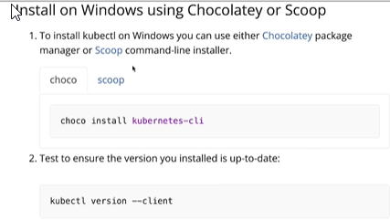

That’s all that is required, minikube, cubectl and VS Code.

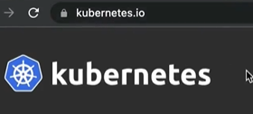



IP assigned to the virtual machine which is running our Kubernetes node created by minikube.

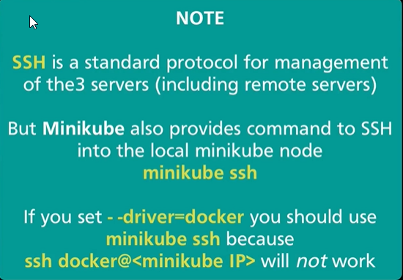



Once inside the node, list the docker containers